Two way Communication

Prepare new app in angular with name

* ng new parent ///parent is the name of app

change the directory or select the folder containing name of app

* cd parent

prepare child component inside the app

* ng g c child //child is name of component

**Communication from parent to the child**

Goto **app.component.html** and add the below code

<h1>Component Interaction</h1>

<app-child></app-child>

**-**to start the app

- ng serve

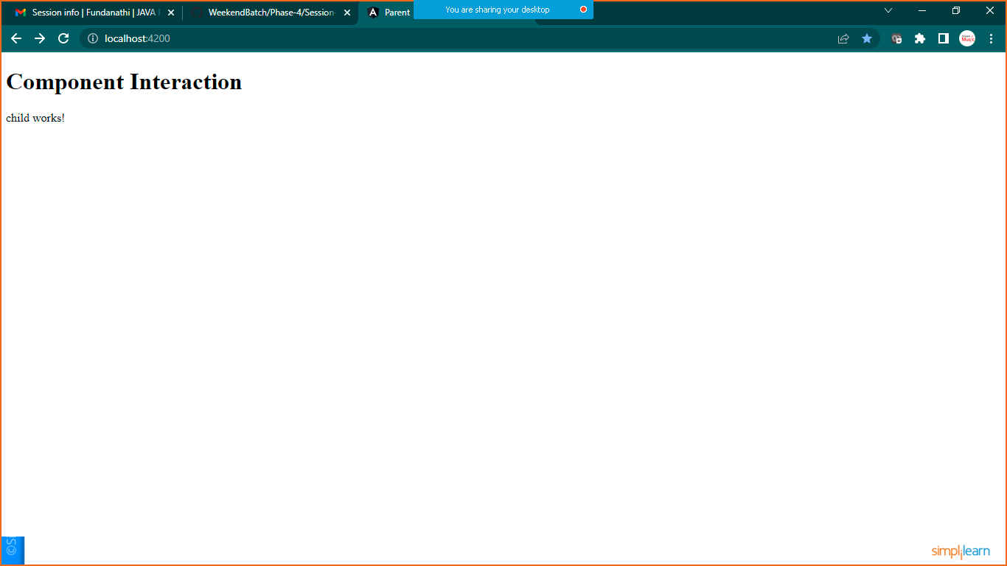

Its working…

Now go to **app.component.html** and add the below code

<h1>Component Interaction</h1>

<h1>Parent Component</h1>

<!--Parent to the child Communication-->

<input type="text" (keyup)="0" #ptext>

<app-child [pdata="ptext.value"]></app-child>

Now goto **child.component.ts**

import { Component, OnInit } from '@angular/core';

@Component({

  selector: 'app-child',

  templateUrl: './child.component.html',

  styleUrls: ['./child.component.css'],

  inputs:['pdata'],

})

export class ChildComponent implements OnInit {

  pdata:string="";

  constructor() { }

  ngOnInit(): void {

  }

}

**To get the value in child component**

**Goto> child.component.html**

<h2>child works!</h2>

<p>Value Coming From Parent Component: <b>{{pdata}} </b></p>

**Save it and now , you will be able to send data from parent to child**

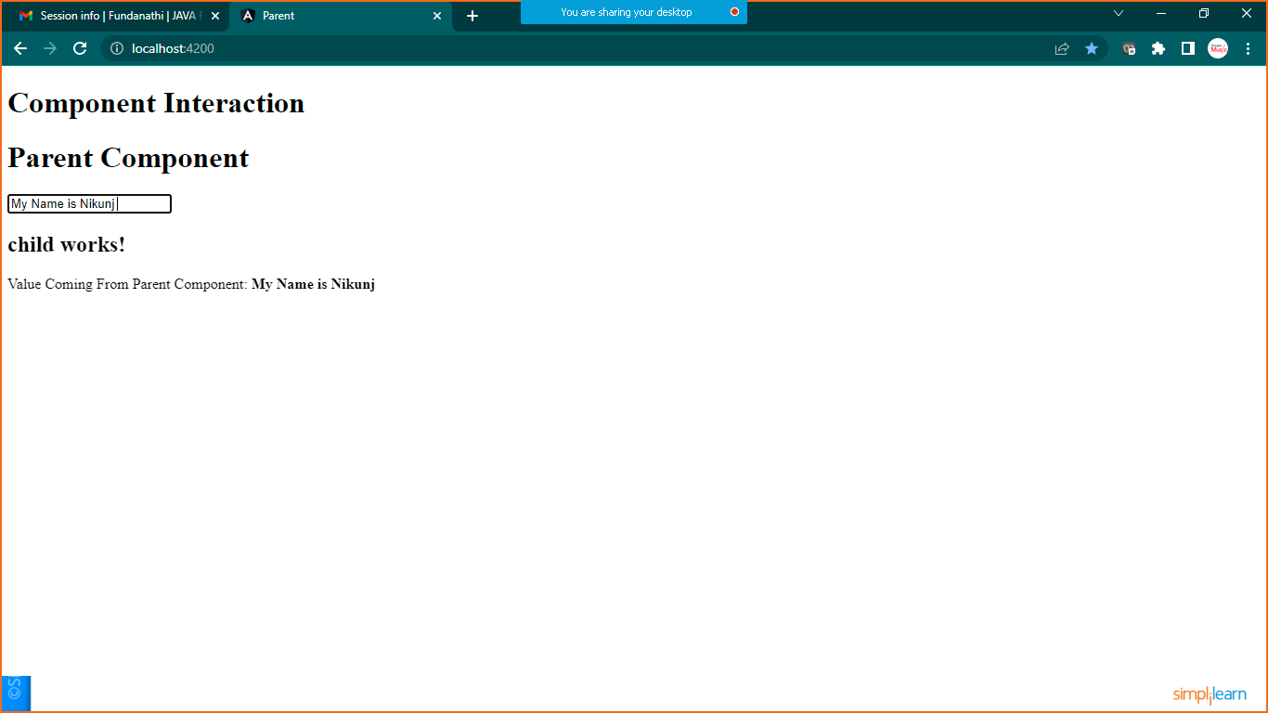

CHILD TO PARENT COMMUNICATION

Child.component.html

<h2>child works!</h2>

<p>Value Coming From Parent Component: <b>{{pdata}} </b></p>

<input type="text" #cdata (keyup)="onChange(cdata.value)"

Now goto **child.component.ts**

import { Component, EventEmitter, OnInit } from '@angular/core';

@Component({

  selector: 'app-child',

  templateUrl: './child.component.html',

  styleUrls: ['./child.component.css'],

  inputs:['pdata'],

  outputs:['cevent']

})

export class ChildComponent implements OnInit {

  pdata:string=""

  constructor() { }

  ngOnInit(): void {

  }

  cevent= new EventEmitter<string>();

  onChange(value:string){

        this.cevent.emit(value);

  }

}

Lets access this value in parent component

Goto> **app.component.html**

<h1>Component Interaction</h1>

<h1>Parent Component</h1>

<!--Parent to the child Communication-->

<input type="text" (keyup)="0" #ptext>

<!--Child to parent communication-->

<p>Value Received From Child Component  :<b>{{cdata}}</b></p>

<app-child [pdata]="ptext.value" (cevent)="cdata=$event"></app-child>

Goto> **app.component.ts**

import { Component } from '@angular/core';

@Component({

  selector: 'app-root',

  templateUrl: './app.component.html',

  styleUrls: ['./app.component.css']

})

export class AppComponent {

  title = 'parent';

  cdata:string=""

}

Save it and check the output

